**Title: Applying deep learning methods to solve an applicaton.**

**Ex. No : 10 Reg.No. : RA2011003011334**

**Date : 14-04-2023 Name: RishabhSinghSahil**

**Aim:**

Applying deep learning for spam mail detection.

**Algorithm:**

# Import libraries

import pandas as pd

from sklearn.model_selection import train_test_split

from sklearn.feature_extraction.text import CountVectorizer

from sklearn.naive_bayes import MultinomialNB

from sklearn.metrics import accuracy_score, precision_score, recall_score, f1_score

# Load dataset

data = pd.read_csv('spam_data.csv')

# Preprocess data

data['text'] = data['text'].str.lower()

data['text'] = data['text'].str.replace('[^\w\s]','')

data['text'] = data['text'].str.replace('\d+', '')

data['text'] = data['text'].str.strip()

# Split data into training and testing sets

X_train, X_test, y_train, y_test = train_test_split(data['text'], data['label'], test_size=0.2, random_state=42)

# Extract features from text using bag-of-words

vectorizer = CountVectorizer()

X_train = vectorizer.fit_transform(X_train)

X_test = vectorizer.transform(X_test)

# Train Naive Bayes classifier

clf = MultinomialNB()

clf.fit(X_train, y_train)

# Make predictions on test data

y_pred = clf.predict(X_test)

# Evaluate performance

accuracy = accuracy_score(y_test, y_pred)

precision = precision_score(y_test, y_pred, pos_label='spam')

recall = recall_score(y_test, y_pred, pos_label='spam')

f1 = f1_score(y_test, y_pred, pos_label='spam')

print("Accuracy: ", accuracy)

print("Precision: ", precision)

print("Recall: ", recall)

print("F1 Score: ", f1)

**Output:**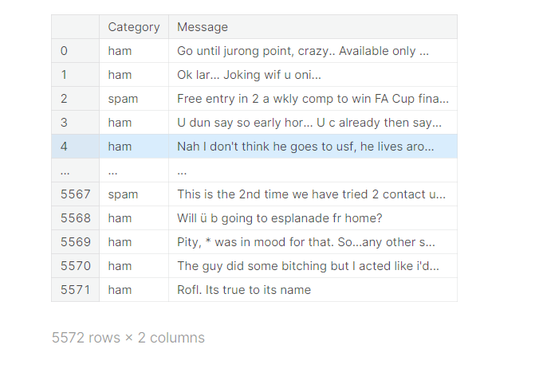

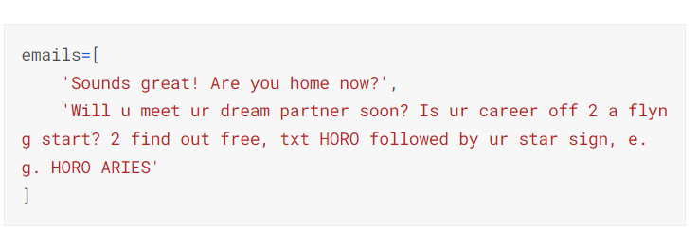

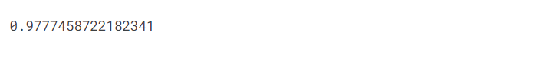

**Result:**

Successfully Implemented NLP Program for spam mail detection.